Module 5 – Question 1
Question Name: Power of Two
Platform: LeetCode
Programming Language: C
Problem URL: https://leetcode.com/problems/power-of-two/
Problem Statement
Given an integer n, return true if it is a power of two. Otherwise, return false.
An integer n is a power of two if there exists an integer x such that n = 2^x.
Input Format
A single integer n.
Output Format
Return true if n is a power of two; otherwise, return false.
Constraints
- -2^31 <= n <= 2^31 - 1
Sample Input 1
1
Sample Output 1
true
Explanation
2^0 = 1.
Sample Input 2
16
Sample Output 2
true
Explanation
2^4 = 16.
Sample Input 3
3
Sample Output 3
false
Code Screenshot
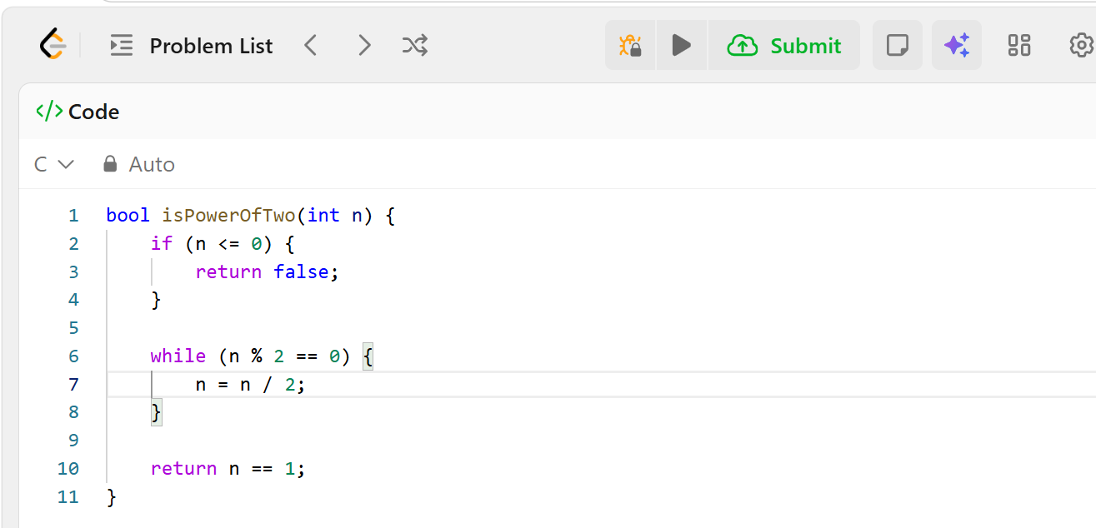Output Screenshot
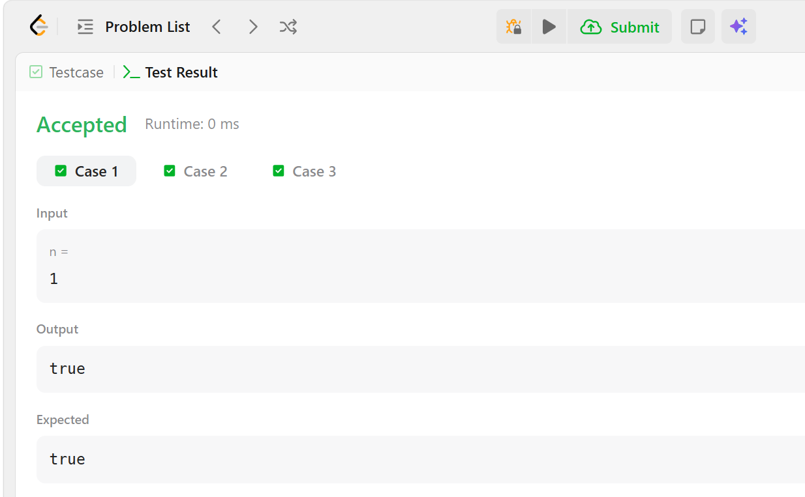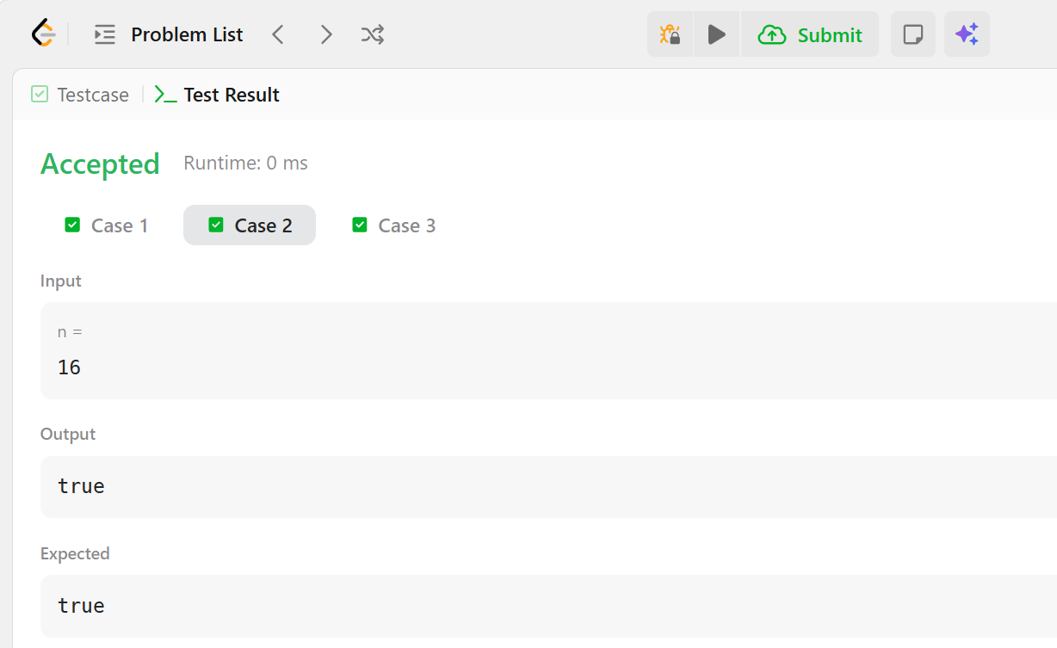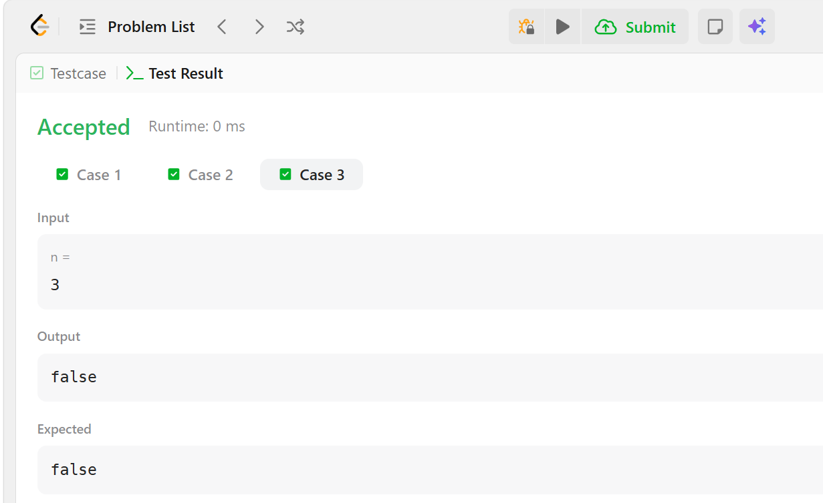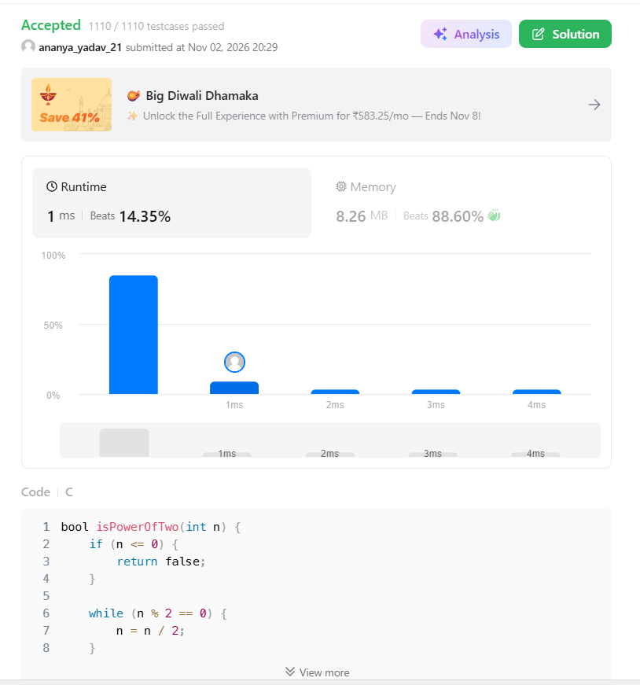
Result

The program checks whether the given integer is a power of two. Submitted on LeetCode.

